Tech Mart Sales Analysis

- Develop tables for products and sales with specific fields
  - Write a query to create a product table with the following fields: product ID, product name, and category.
  - Write a query to create a sales table with fields: sale ID, sale date, and quantity sold.

- CREATE TABLE Products (
- product_id INTEGER PRIMARY KEY,
- product_name TEXT NOT NULL,
- category TEXT NOT NULL
- );

CREATE TABLE Sales (
sale_id INTEGER PRIMARY KEY,
product_id INTEGER NOT NULL,
sale_date TEXT NOT NULL,
quantity_sold INTEGER NOT NULL,
FOREIGN KEY (product_id) REFERENCES Products(product_id)
);

- Insert values into Products and Sales
  - Write a query to insert the following data into the product and sales tables:
Product table:
(product_id, product_name, category)
(1, 'Laptop', 'Electronics')
(2, 'Smartphone', 'Electronics')
(3, 'Coffee Maker', 'Appliances')
(4, 'Running Shoes', 'Apparel')

INSERT INTO Sales (sale_id, product_id, sale_date, quantity_sold)
VALUES
(1, 1, '2023-01-05', 10),
(2, 2, '2023-01-10', 15),
(3, 3, '2023-01-15', 8),
(4, 4, '2023-01-20', 12),
(5, 1, '2023-02-05', 14),
(6, 2, '2023-02-12', 18),
(7, 3, '2023-02-18', 9),
(8, 4, '2023-02-25', 16),
(9, 1, '2023-03-06', 20),
(10, 2, '2023-03-11', 22),
(11, 3, '2023-03-16', 13),
(12, 4, '2023-03-24', 18),
(13, 1, '2023-04-05', 16),
(14, 2, '2023-04-10', 24),
(15, 3, '2023-04-18', 11),
(16, 4, '2023-04-28', 19),
(17, 1, '2023-05-07', 21),
(18, 2, '2023-05-12', 28),
(19, 3, '2023-05-19', 15),
(20, 4, '2023-05-26', 22),
(21, 1, '2023-06-04', 18),
(22, 2, '2023-06-13', 26),
(23, 3, '2023-06-21', 14),
(24, 4, '2023-06-29', 20),
(25, 1, '2024-01-06', 24),
(26, 2, '2024-01-11', 30),
(27, 3, '2024-01-17', 16),
(28, 4, '2024-01-23', 25),
(29, 1, '2024-02-04', 26),
(30, 2, '2024-02-09', 32),
(31, 3, '2024-02-15', 18),
(32, 4, '2024-02-21', 27),
(33, 1, '2024-03-03', 28),
(34, 2, '2024-03-10', 35),
(35, 3, '2024-03-18', 20),
(36, 4, '2024-03-26', 29),
(37, 1, '2024-04-05', 25),
(38, 2, '2024-04-13', 34),
(39, 3, '2024-04-19', 19),
(40, 4, '2024-04-27', 31),
(41, 1, '2024-05-06', 30),
(42, 2, '2024-05-14', 38),
(43, 3, '2024-05-20', 22),
(44, 4, '2024-05-29', 33),
(45, 1, '2024-06-04', 27),
(46, 2, '2024-06-12', 36),
(47, 3, '2024-06-18', 21),
(48, 4, '2024-06-25', 32),
(49, 1, '2024-06-28', 29),
(50, 2, '2024-06-30', 40);

- Calculate the total sales for each product
  - Write a SQL query using the SUM() OVER Window Functions to calculate the total sales for each product.
- SELECT DISTINCT
- p.product_id,
- p.product_name,
- p.category,
- SUM(s.quantity_sold) OVER (
- PARTITION BY p.product_id
- ) AS total_units_sold
- FROM Products AS p
- JOIN Sales AS s
- ON s.product_id = p.product_id
- ORDER BY total_units_sold DESC;

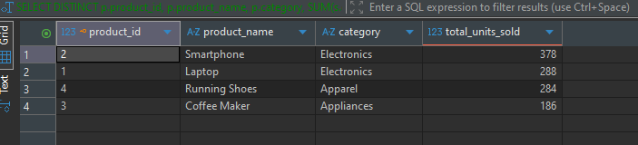

- Analyze the monthly sales trend over the past years
  - Develop a SQL query utilizing the SUM() OVER Function to analyze the monthly sales trend over the past years
- WITH monthly_sales AS (
- SELECT
- strftime('%Y-%m', sale_date) AS sale_month,
- SUM(quantity_sold) AS monthly_units
- FROM Sales
- GROUP BY strftime('%Y-%m', sale_date)
- )
- SELECT
- sale_month,
- monthly_units,
- SUM(monthly_units) OVER (
- ORDER BY sale_month
- ROWS BETWEEN UNBOUNDED PRECEDING AND CURRENT ROW
- ) AS cumulative_units
- FROM monthly_sales
- ORDER BY sale_month;

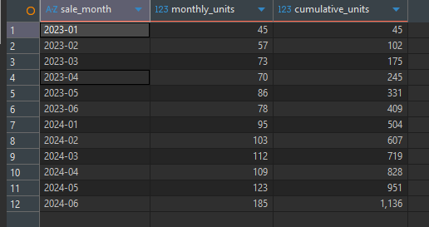

Identify the top N products with the highest total sales
  - Create a SQL query using the RANK() window function to identify the top N products with the highest total sales.
- WITH product_totals AS (
- SELECT
- p.product_id,
- p.product_name,
- SUM(s.quantity_sold) AS total_units_sold
- FROM Products AS p
- JOIN Sales AS s
- ON s.product_id = p.product_id
- GROUP BY p.product_id, p.product_name
- ),
- ranked_products AS (
- SELECT
- product_id,
- product_name,
- total_units_sold,
- RANK() OVER (
- ORDER BY total_units_sold DESC
- ) AS product_rank
- FROM product_totals
- )
- SELECT
- product_rank,
- product_id,
- product_name,
- total_units_sold
- FROM ranked_products



